"HEAVENS LIGHT IS OUR GUIDE"

**RAJSHAHI UNIVERSITY OF ENGINEERING & TECHNOLOGY**



**DEPARTMENT OF COMPUTER SCIENCE & ENGINEERING**

**COURSE Code:** CSE 3206

**COURSE TITLE**: Software Engineering Sessional

**Report:** 01

|  |  |
| --- | --- |
| **SUBMITTED BY:**  **Name**: Md. Shifat Alam  **Roll** : 2003135  **Section** : C | **SUBMITTED TO:**  Farjana Parvin  Lecturer  Department of CSE, RUET |

**Title:** Introduction to Git and GitHub.

**Procedure:**

1. Create a repository in GitHub and copy the repository URL.

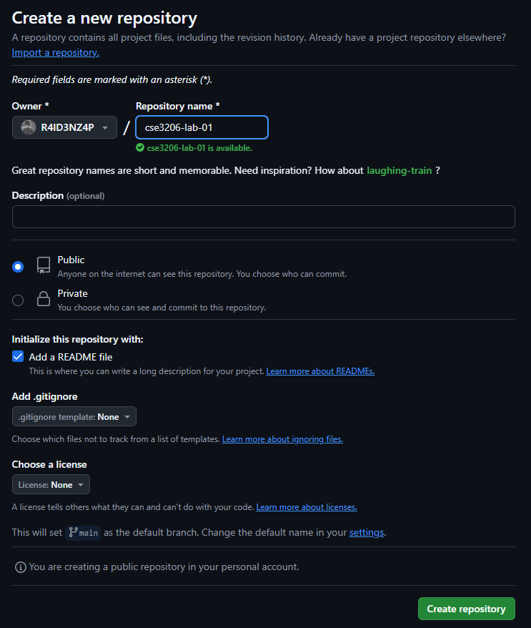

Fig. 1.1: Creating repository

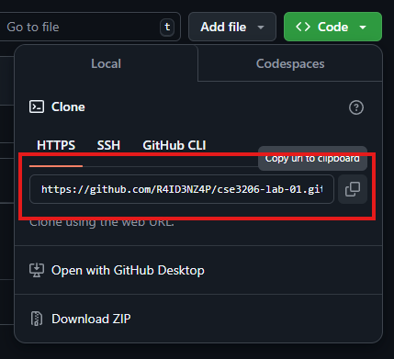

Fig. 1.2: Copy the URL

1. Clone the repository in local machine using **git clone** command.

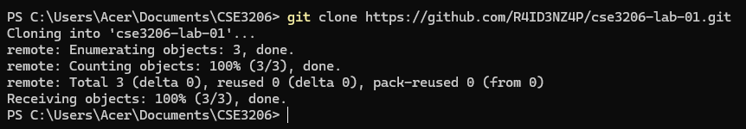

Fig. 2: Cloning the repository using Terminal

1. Create a file in the directory and upload it to GitHub using **git add**, **git commit** and **git push** commands.

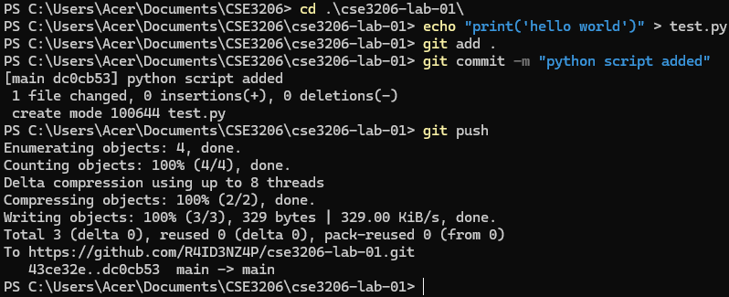

Fig. 3: Creating and uploading a file to GitHub using Git.